Report For Cross Site Scripting

**Title**: Cross Site Scripting

**Domain**: Vulnweb.com

**Subdomain**: testasp.vulnweb.com

**Steps**:

Step 1: Visit <http://testasp.vulnweb.com/>

Step 2: On the top menu you will find a search option.

Step 3: Click on it and you will be prompted with the Search box.

Step 4: You can intercept the request in Burp Suite

Step 5: Now you can find different payloads for XSS.

Step 6: Send the request to the intruder and paste all the payloads.

Step 7: Try to find a successful payload for XSS.

Step 8: Prepare a report for it.

**Impact**: Impact of cross site is vulnerabilities can vary from vary from one web application to another. It ranges from session hijacking to credential theft and other security vulnerablilites. It will Harm to your website.

**Mitigation**: Mitigations of XSS typically involve sanitizing data input ,escaping all output , and re-structing applications so code is loaded from well-defined endpints.

Recordings:

[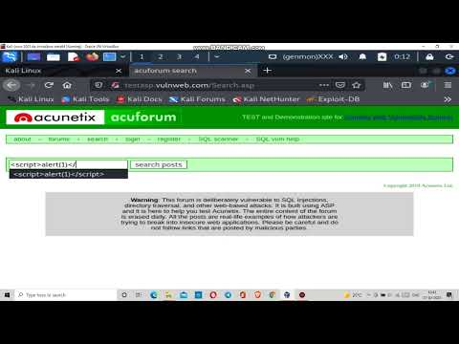](https://www.youtube.com/embed/6YlYRPQvDYw?feature=oembed)

Screenshot: